Black Is The Colour
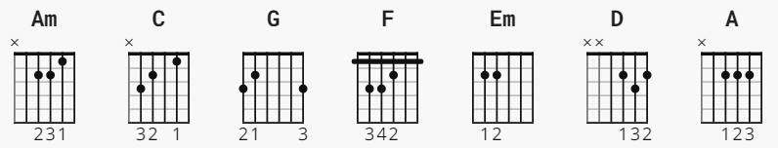
Am C G Am
Black is the colour of my true loves hair
C F G Em
Her lips are like some roses fair
F G Em
She's the sweetest smile and the gentlest hands
Am C G Am
And I love the ground where on she stands.
Am C G Am
I love my love and well she knows
C F G Am
I love the ground where on she goes
C F G Em
I wish the day it soon would come
Am C G Am
when she and I could be as one.
(KEY CHANGE IN LAST VERSE, OPTIONAL)
D G A D
I go to the clyde and I mourn and weep
G A D
for satisfied I neer can be
G A D G A
I write her a letter, just a few short lines and suffer death
D
a thousand times.

