Hello and welcome to my digital space!
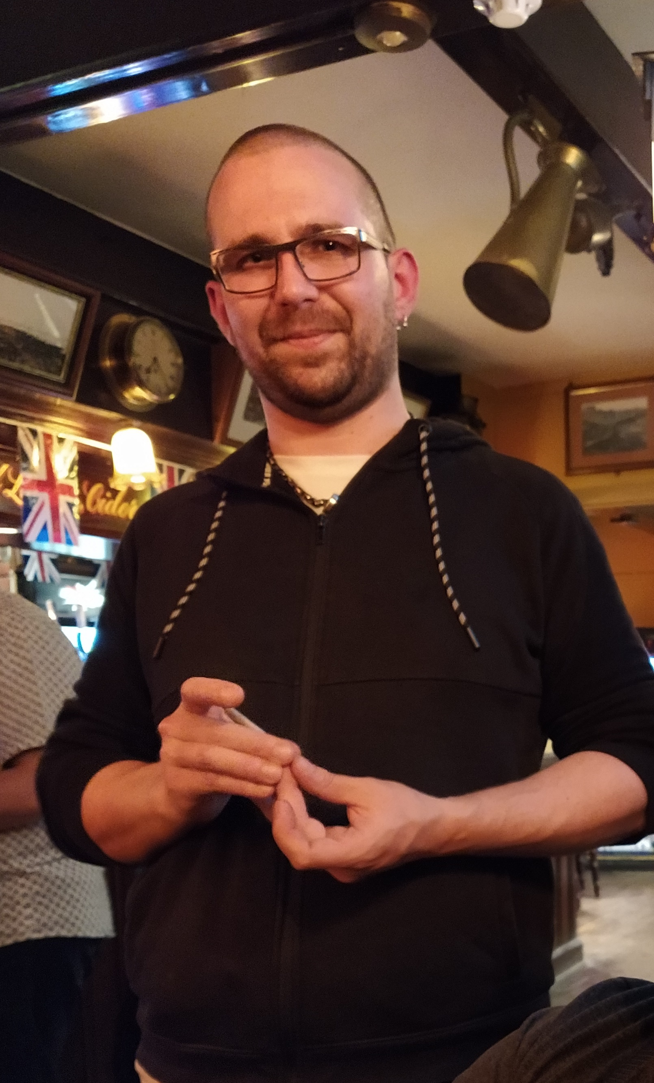Gabor
I'm Gabor Kun, an Electronics Specialist with a passion for innovation and problem-solving. Through this website, I invite you to explore my journey in the realm of electronics.
Within these virtual pages, you'll find a collection of my slowly accumulating ideas, projects, articles, and hacks. It's not just about technical stuff; I'll post whatever I find interesting.
Whether you're here to explore my portfolio, delve into my latest projects, or simply connect with a fellow enthusiast, I'm thrilled to have you along for the ride. Feel free to browse, engage, and reach out—I'm always eager to collaborate and exchange ideas.
Thank you for visiting, and I look forward to sharing this journey with you!
Please note that this website is currently under development. I'm working on adding more content and features to provide you with the best experience. Thank you for your patience and understanding.

Tools
- RF - Coaxial Cable Charts
- RF - Coaxial Connectors
- Transistor packages

Ideas
- Signal Generator
- Band Pass Filter in Falstad

Projects
- Husqvarna-Viking Designer 1 Repair
- Signal Hound VSG25 - Modification for better frequency stability
- Bi-Directional PSU #PWM #PFC #Inverter
- microPython Pulse Generator #Lez #RF_switch_test

Darma
- Eight Sufferings
- The Question
- Thoughts and Emotions
- Erroneous Views and Distorted Self-image

Guitar
- Wayfaring Stranger - The Longest Johns
- Black Is The Colour
- The Parting Glass
- Enjoy The Ride - Morcheeba
- You've Got A Friend - James Taylor
- Who Knows - Marion Black

To Learn about
- GDB - C/C++ Debugger
- Ghidra Decompiler
Edit Sidebar..

