Signal Hound VSG25 - Modification for better frequency stability
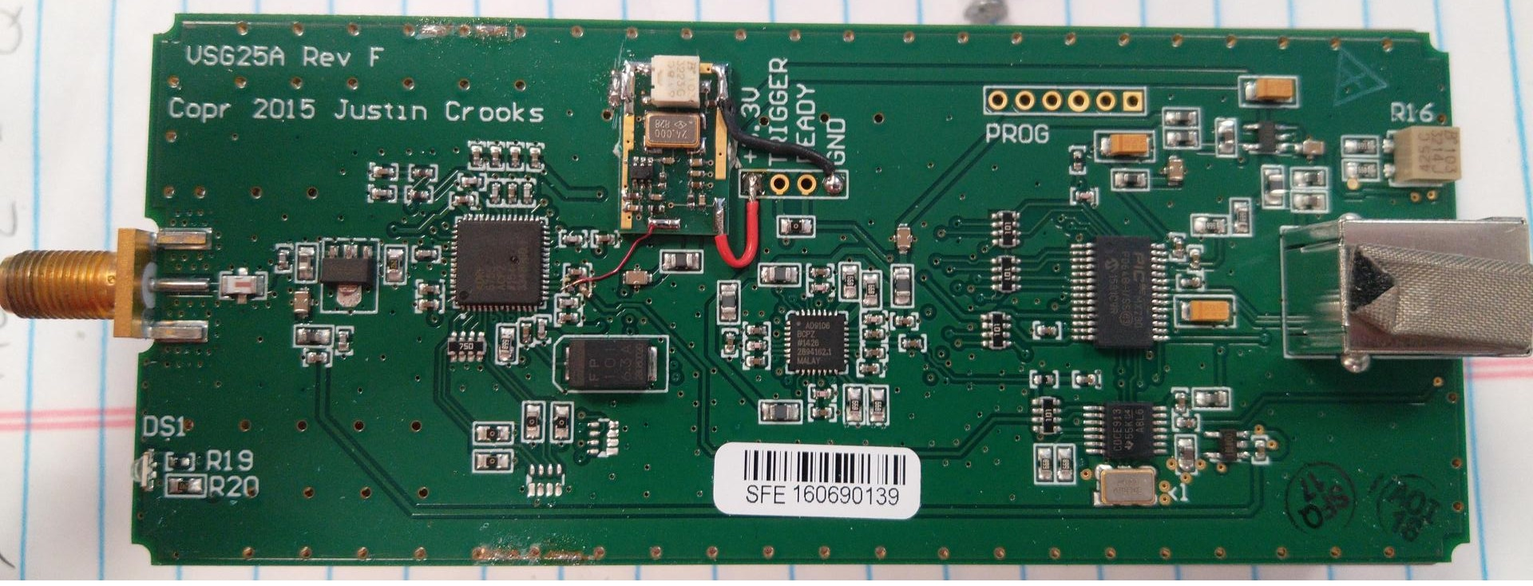Signal Hound VSG25 - Disassembled
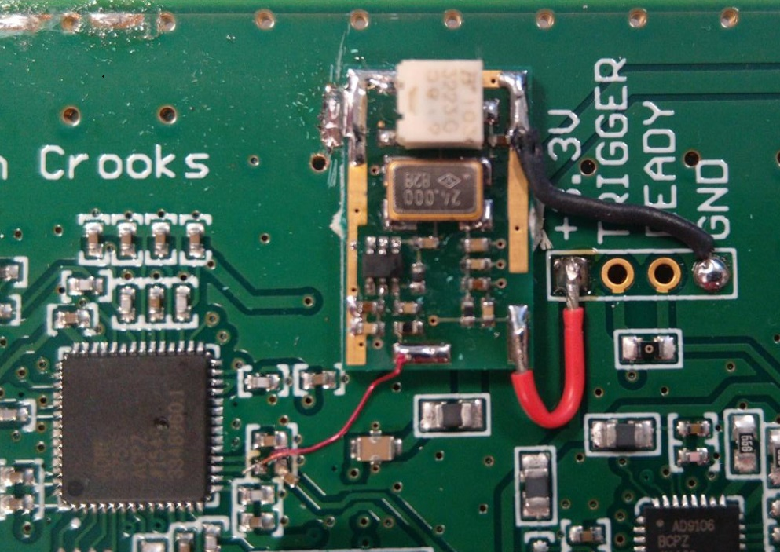Signal Hound VSG25 - Modification Closeup
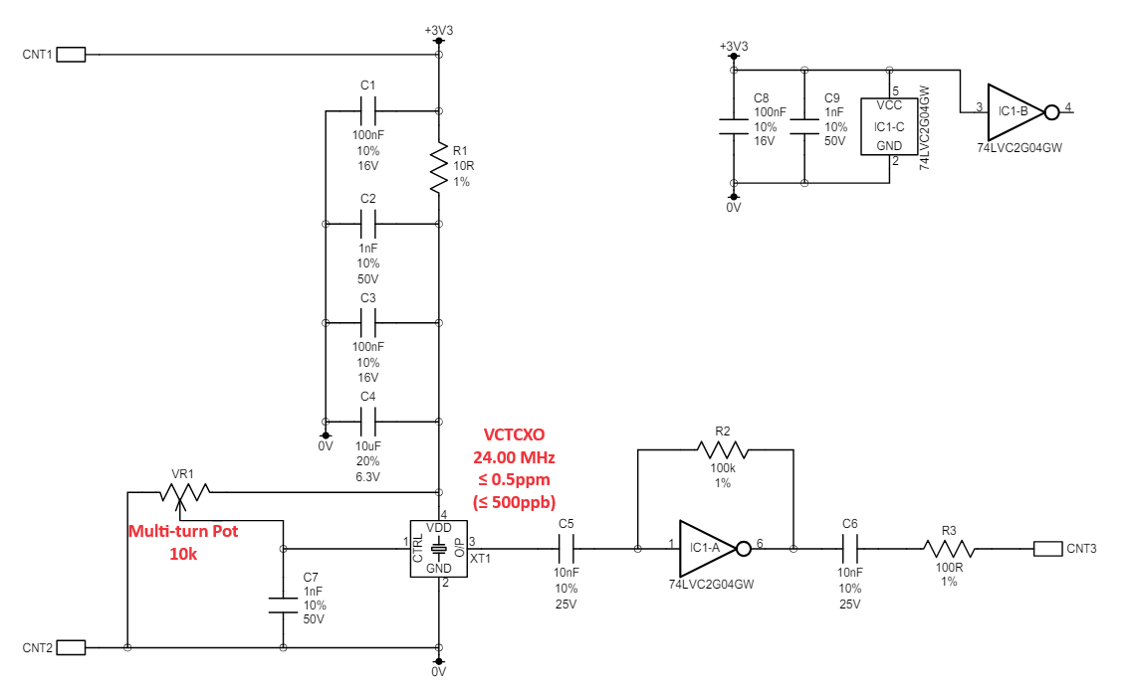Signal Hound VSG25 - Mod Schematic
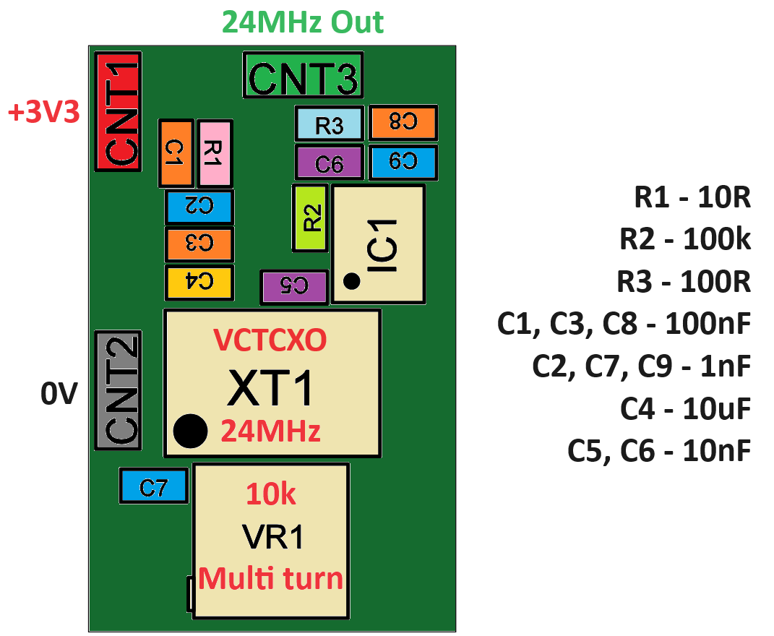Signal Hound VSG25 - Mod Layout

