Wayfaring Stranger - The Longest Johns
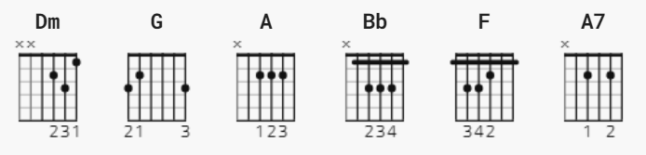
[Verse 1]
Dm
I am a poor wayfaring stranger
G Dm
Travelling through this world of woe
Dm
There is no sickness, toil or danger
G A Dm
In that fair land to which I go
[Chorus]
Bb F
I'm going home to see my mother
Bb A A A7 *or T3
I'm going home no more to roam
A7 Dm
I'm just going over Jordan
G A Dm
I'm just going over home
[Verse 2]
Dm
I know dark clouds will hover on me
G Dm
I know my path is rough and steep
Dm
But golden fields lie out before me
G A Dm
Where weary eyes no more shall weep
[Chorus]
Bb F
I'm going home to see my father
Bb A A A7 *or T3
I'm going home no more to roam
A7 Dm
I'm just going over Jordan
G A Dm
I'm just going over home
[Verse 3]
Dm
I'll soon be free from every trial
G Dm
This form shall rest beneath the sun
Dm
I'll drop the cross of self-denial
G A Dm
And enter in at home with God
[Chorus]
Bb F
I'm going home to meet my saviour
Bb A A A7 *or T3
I'm going home no more to roam
Dm
I'm just going over Jordan
G A Dm A
I'm just going over home
Bb F
I'm going home to meet my saviour
Bb A A A7 *or T3
I'm going home no more to roam
Dm
I'm just going over Jordan
G A Dm
I'm just going over home
If you want to add more fingerstyle to it, the tabs are taken (as best as possible in the absence
of a live
recording for now) from the banjo melody.
During the verses, it alternates between T1 and T2.
During the chorus, play the full chords.
T1
Dm (strum)
e|-1-----1-^0---------------|-1----1-^0--------------|
B|-3--3-------3--1-----1--3-|-3--3------3--1-----3---|
G|-2----------------2-------|-2---------------2------|
D|--------------------------|------------------------|
A|--------------------------|------------------------|
E|--------------------------|------------------------|
T2
G Dm
e|----------------|
B|--3-3-3-3-3-3-3-|
G|-2-2-2-2-2-2-2--|
D|----------------|
A|----------------|
E|----------------|
T3 (electric guitar part)
e|--5---3---------|
B|----------3-----|
G|----------------|
D|----------------|
A|----------------|
E|----------------|

