You've Got A Friend - James Taylor

Simplified Version
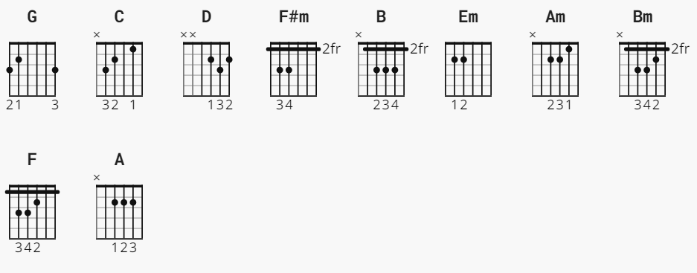
[Intro]
G C D G F#m B
[Verse 1]
Em B Em B Em
When you're down and troubled and you need a helping hand,
Am D G
and nothing, oh, nothing is going right,
F#m B Em B Em
close your eyes and think of me and soon I will be there
Am Bm D
to brighten up even your darkest night.
[Chorus]
G C Am
You just call out my name, and you know wherever I am,
G D
I'll come running to see you again.
G C Em
Winter, spring, summer, or fall, all you got to do is call
C Bm Am D
and I'll be there, yeah, yeah, yeah.
D G C G F#m B
You've got a friend.
[Verse 2]
B Em B Em B Em
If the sky above you should turn dark and full of clouds,
Am D G
and that old north wind should begin to blow,
F#m B Em B Em
keep your head together and call my name out loud.
Am Bm D
Soon I'll be knocking upon your door.
[Chorus]
G C Am
You just call out my name, and you know wherever I am,
G D
I'll come running to see you again.
G C Em
Winter, spring, summer, or fall, all you got to do is call
C Bm Am D
and I'll be there, yeah, yeah, yeah.
[Bridge]
F C
Hey ain't it good to know that you've got a friend when
G C F
people can be so cold. They'll hurt you and desert you.
Em A
they'll take your soul if you let them.
D
Oh yeah, but don't you let them.
[Chorus]
G C Am
You just call out my name, and you know wherever I am,
G D
I'll come running to see you again.
G C Em
Winter, spring, summer, or fall, all you got to do is call
C Bm Am D
and I'll be there, yes I will.
G C G
You've got a friend. You've got a friend.
C G
Ain't it good to know you've got a friend?
C G
Ain't it good to know you've got a friend?
C G
Oh, yeah, yeah. You've got a friend.

Original Version
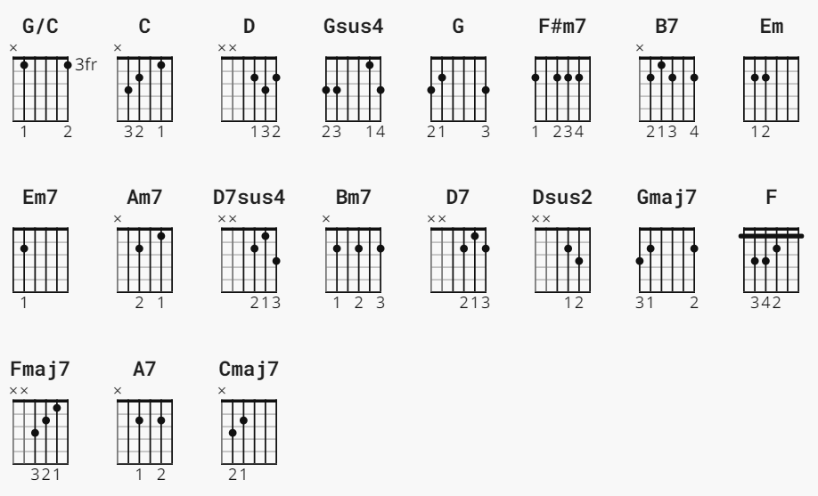
[Intro]
G/C C D Gsus4 G F#m7 B7
[Verse 1]
Em B7 Em B7 Em7
When you're down and troubled and you need a helping hand,
Am7 D7sus4 G Gsus4 G
and nothing, oh, nothing is going right,
F#m7 B7 Em B7 Em Em7
close your eyes and think of me and soon I will be there
Am7 Bm7 D7sus4 D7 Dsus2 D7
to brighten up even your darkest night.
[Chorus]
G Gmaj7 C Am7
You just call out my name, and you know wherever I am,
G Gmaj7 D7sus4 D7 Dsus2 D7
I'll come running to see you again.
G Gmaj7 C Em
Winter, spring, summer, or fall, all you got to do is call
C Bm7 Am7 D7sus4
and I'll be there, yeah, yeah, yeah.
D7sus4 G/C C Gsus4 G F#m7 B7
You've got a friend.
[Verse 2]
B7 Em B7 Em B7 Em7
If the sky above you should turn dark and full of clouds,
Am7 D7sus4 G Gsus4 G
and that old north wind should begin to blow,
F#m7 B7 Em B7 Em7
keep your head together and call my name out loud.
Am7 Bm7 D7sus4 D7 Dsus2 D7
Soon I'll be knocking upon your door.
[Chorus]
G Gmaj7 C Am7
You just call out my name, and you know wherever I am,
G Gmaj7 D7sus4 D7 Dsus2 D7
I'll come running to see you again.
G Gmaj7 C Em
Winter, spring, summer, or fall, all you got to do is call
C Bm7 Am7 D7sus4
and I'll be there, yeah, yeah, yeah.
[Bridge]
F C
Hey ain't it good to know that you've got a friend when
G Gmaj7 C Fmaj7
people can be so cold. They'll hurt you and desert you.
Em A7
they'll take your soul if you let them.
D7sus4 D7sus4 D7
Oh yeah, but don't you let them.
[Chorus]
G Gmaj7 Cmaj7 Am7
You just call out my name, and you know wherever I am,
G Gmaj7 D7sus4 D7 Dsus2 D7
I'll come running to see you again.
G Gmaj7 C Em
Winter, spring, summer, or fall, all you got to do is call
C Bm7 Am7 D7sus4
and I'll be there, yes I will.
G C G
You've got a friend. You've got a friend.
C G
Ain't it good to know you've got a friend?
C G
Ain't it good to know you've got a friend?
C Gsus4 G
Oh, yeah, yeah. You've got a friend.

